Question 1:
Code:
import pandas as pd
import numpy as np
import matplotlib.pyplot as plt
from sklearn.cluster import AgglomerativeClustering
!wget -O shopping-data.csv https://gist.githubusercontent.com/JuanPQ26/07a8c26ab285792555b74c1e31aaa10d/raw/Mall_Customers.csv
data = pd.read_csv('shopping-data.csv')
print("First 5 rows of dataset:")
print(data.head())
X = data[['Annual Income (k$)', 'Spending Score (1-100)']].values
def agglomerative_plot(X, linkage_method):
cluster_model = AgglomerativeClustering(n_clusters=5, linkage=linkage_method)
labels = cluster_model.fit_predict(X)
plt.figure(figsize=(7,5))
colors = ['r','g','b','c','m']
for i in range(5):
cluster_points = X[labels==i]
plt.scatter(cluster_points[:,0], cluster_points[:,1], color=colors[i], s=100, label=f'Cluster {i+1}')

plt.title(f"Agglomerative Clustering ({linkage_method} linkage)")
plt.xlabel("Annual Income (k$)")
plt.ylabel("Spending Score (1-100)")
plt.legend()
plt.grid(True)
plt.show()
for linkage in ['ward', 'complete', 'average']:
agglomerative_plot(X, linkage)

Output:
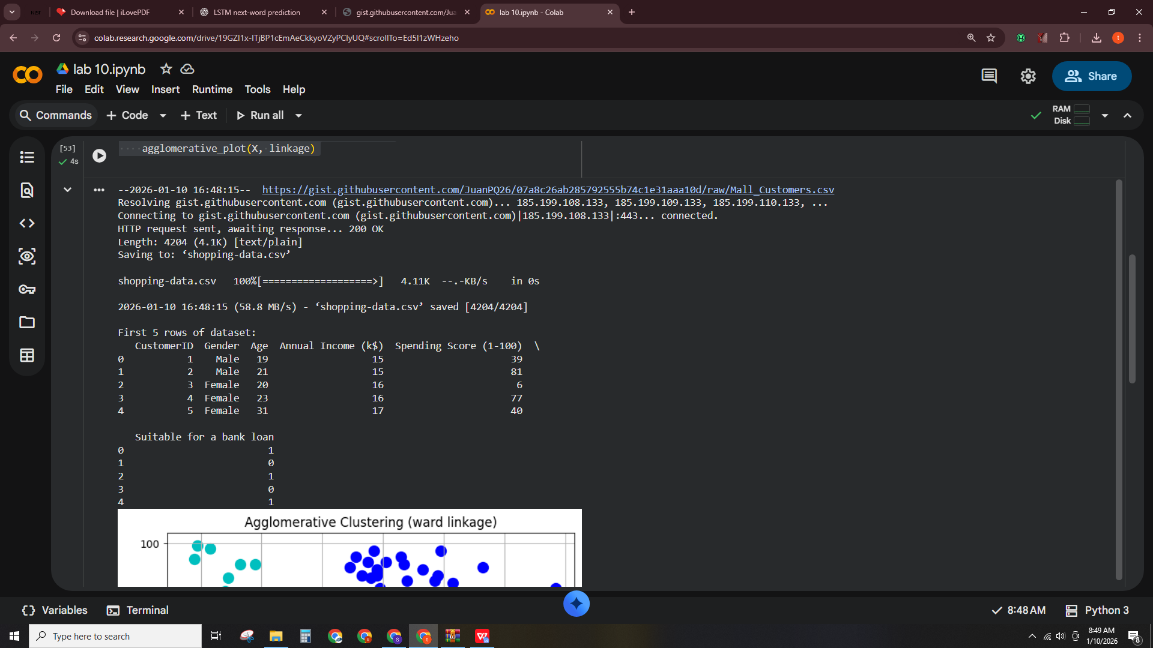
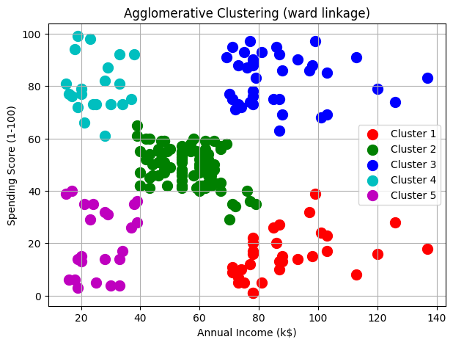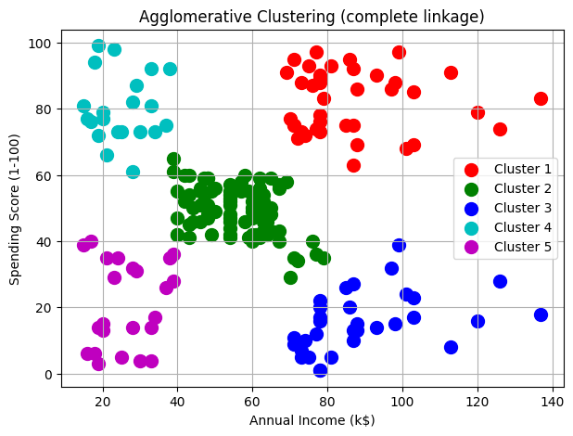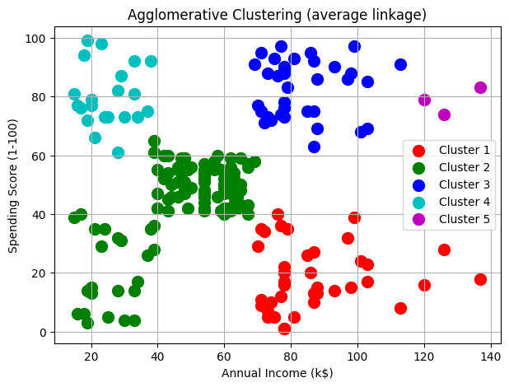

Question 2:
Code:
import pandas as pd
import matplotlib.pyplot as plt
from scipy.cluster.hierarchy import dendrogram, linkage, fcluster
!wget -O shopping-data.csv https://gist.githubusercontent.com/JuanPQ26/07a8c26ab285792555b74c1e31aaa10d/raw/Mall_Customers.csv
data = pd.read_csv('shopping-data.csv')
print("First 5 rows of dataset:")
print(data.head())
X = data[['Annual Income (k$)', 'Spending Score (1-100)']].values
linked = linkage(X, method='ward')
plt.figure(figsize=(12, 6))
dendrogram(linked,
orientation='top',
distance_sort='descending',
show_leaf_counts=True)
plt.title("Dendrogram - Hierarchical Clustering (Ward)")
plt.xlabel("Data Points")
plt.ylabel("Euclidean Distance")
plt.grid(True)
plt.show()
optimal_clusters = 5
labels = fcluster(linked, optimal_clusters, criterion='maxclust')
plt.figure(figsize=(8,6))
colors = ['r','g','b','c','m','y','orange']
for i in range(1, optimal_clusters+1):
plt.scatter(X[labels==i,0], X[labels==i,1],
label=f'Cluster {i}', s=100, color=colors[i-1])
plt.title("Hierarchical Clustering - Final Clusters")
plt.xlabel("Annual Income (k$)")
plt.ylabel("Spending Score (1-100)")
plt.legend()
plt.grid(True)
plt.show()

Output:
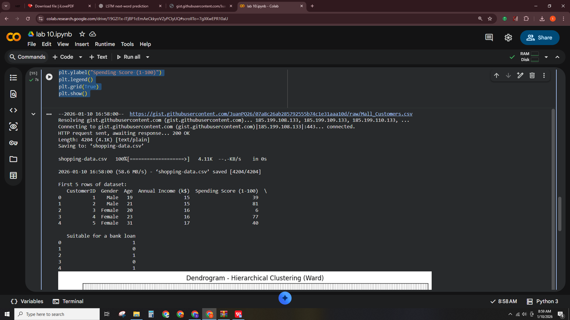
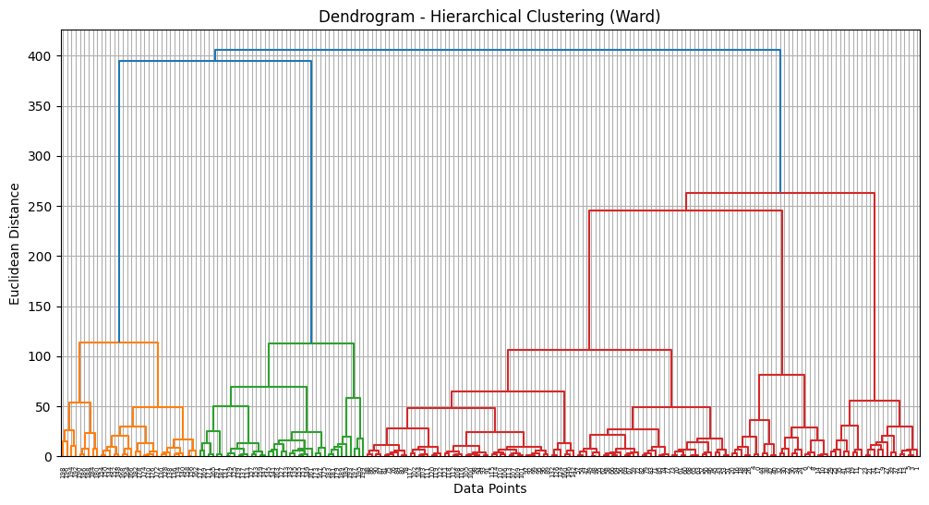
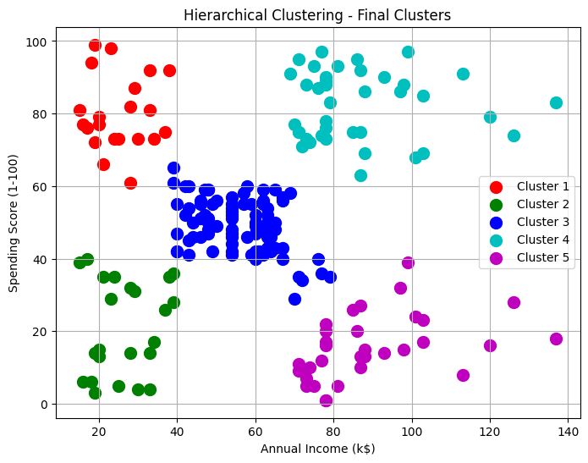
Question 3: Compare Agglomerative vs Divisive Hierarchical Clustering
Code:
import numpy as np
import matplotlib.pyplot as plt
from scipy.cluster.hierarchy import dendrogram, linkage
X = np.array([
[1,2], [2,1], [3,4], [5,7], [3,3],
[8,5], [7,6], [9,8], [6,2], [4,5]
])
linked_agg = linkage(X, method='ward')

plt.figure(figsize=(8,5))
dendrogram(linked_agg,
orientation='top',
distance_sort='descending',
show_leaf_counts=True)
plt.title("Agglomerative Clustering Dendrogram")
plt.xlabel("Points")
plt.ylabel("Euclidean Distance")
plt.grid(True)
plt.show()
split_threshold = 5
labels_div = np.array([0 if x[0] < split_threshold else 1 for x in X])

plt.figure(figsize=(6,5))
colors = ['r','b']
for i in range(2):
plt.scatter(X[labels_div==i,0], X[labels_div==i,1], color=colors[i], s=100, label=f'Cluster {i+1}')
plt.title("Divisive Clustering (Top-down Approximation)")
plt.xlabel("X1")
plt.ylabel("X2")
plt.legend()
plt.grid(True)
plt.show()

Output:
